这张图是用软件MindMaster Pro画出来的

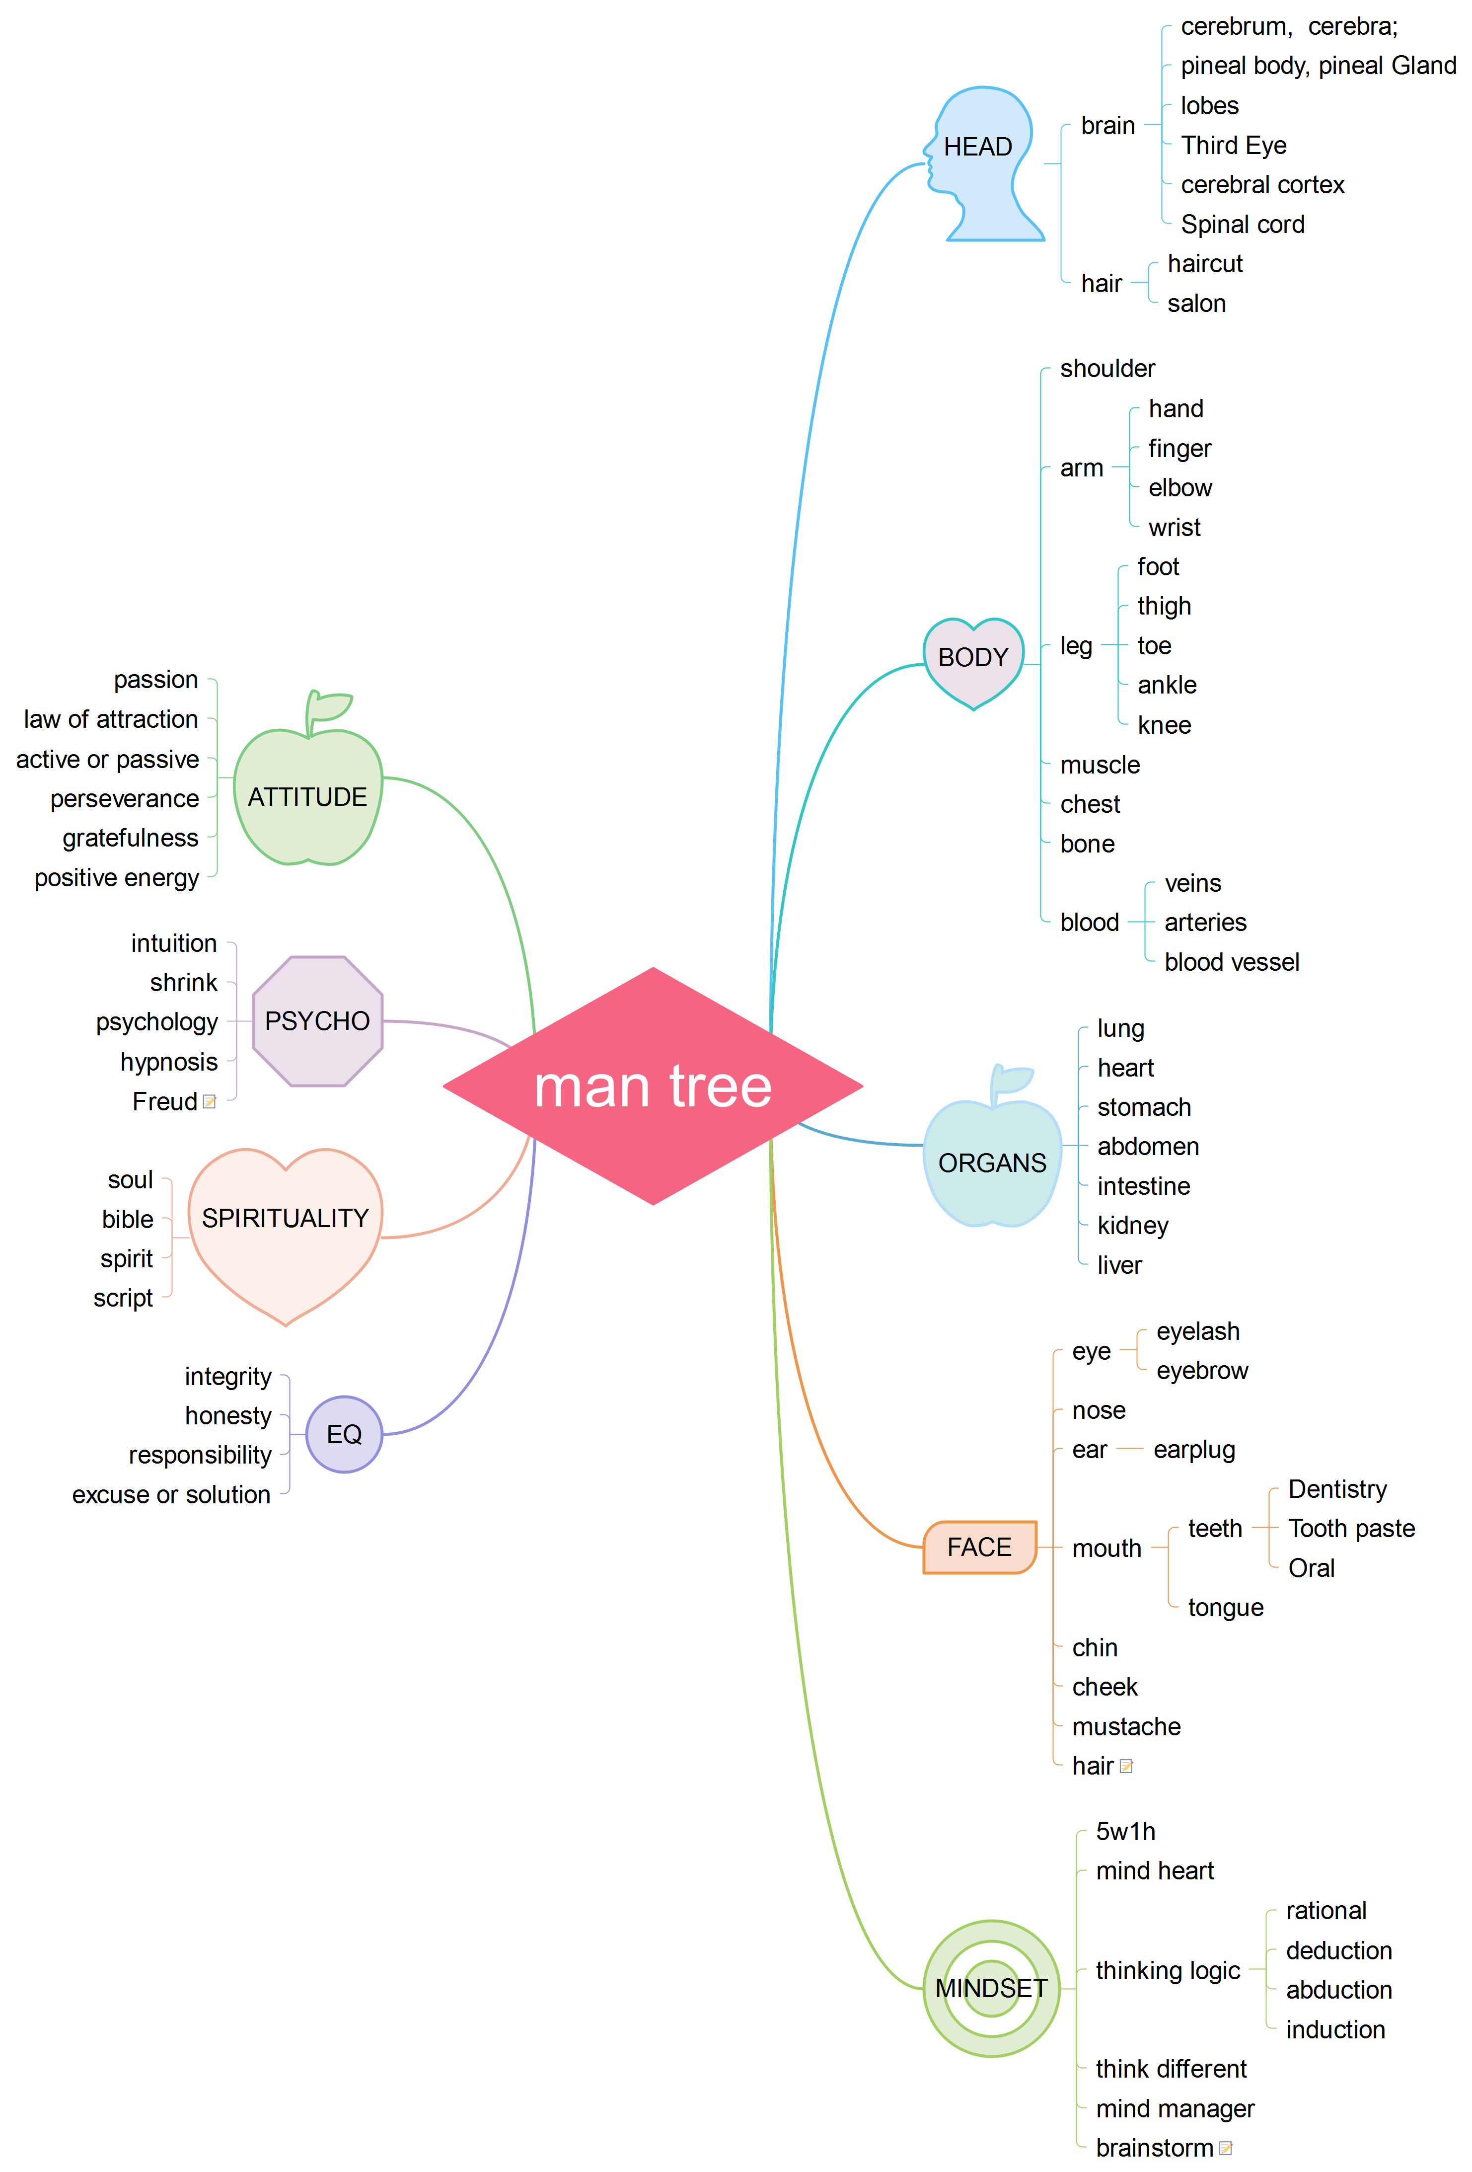 man tree
1. HEAD 1
1.1. brain 2
1.1.1. cerebrum, cerebra; 2
1.1.2. pineal body, pineal Gland 2
1.1.3. lobes 2
1.1.4. Third Eye 2
1.1.5. cerebral cortex 2
1.1.6. Spinal cord 2
1.2. hair 2
1.2.1. haircut 2
1.2.2. salon 2
2. BODY 2
2.1. shoulder 2
2.2. arm 2
2.2.1. hand 2
2.2.2. finger 2
2.2.3. elbow 2
2.2.4. wrist 2
2.3. leg 2
2.3.1. foot 2
2.3.2. thigh 2
2.3.3. toe 3
2.3.4. ankle 3
2.3.5. knee 3
2.4. muscle 3
2.5. chest 3
2.6. bone 3
2.7. blood 3
2.7.1. veins 3
2.7.2. arteries 3
2.7.3. blood vessel 3
3. ORGANS 3
3.1. lung 3
3.2. heart 3
3.3. stomach 3
3.4. abdomen 3
3.5. intestine 3
3.6. kidney 3
3.7. liver 3
4. FACE 3
4.1. eye 3
4.1.1. eyelash 4
4.1.2. eyebrow 4
4.2. nose 4
4.3. ear 4
4.3.1. earplug 4
4.4. mouth 4
4.4.1. teeth 4
4.4.2. tongue 4
4.5. chin 4
4.6. cheek 4
4.7. mustache 4
4.8. hair 4
5. MINDSET 4
5.1. 5w1h 4
5.2. mind heart 4
5.3. thinking logic 4
5.3.1. rational 4
5.3.2. deduction 5
5.3.3. abduction 5
5.3.4. induction 5
5.4. think different 5
5.5. mind manager 5
5.6. brainstorm 5
6. EQ 5
6.1. integrity 5
6.2. honesty 5
6.3. responsibility 5
6.4. excuse or solution 5
7. SPIRITUALITY 5
7.1. soul 5
7.2. bible 5
7.3. spirit 5
7.4. script 5
8. PSYCHO 5
8.1. intuition 5
8.2. shrink 5
8.3. psychology 6
8.4. hypnosis 6
8.5. Freud 6
9. ATTITUDE 6
9.1. passion 6
9.2. law of attraction 6
9.3. active or passive 6
9.4. perseverance 6
9.5. gratefulness 6
9.6. positive energy 6

HEAD
人的头，就是电脑里面的CPU，也就是我们常说的心所在地，心不是指心脏，而是在大脑当中

Brain
这里边的大脑就指的是物质上的大脑，指的是它的物质组成

cerebrum, cerebra;
这个是大脑的学术用语，通常指它的结构

pineal body, pineal Gland
这个是智慧眼的中心

lobes

Third Eye

cerebral cortex

Spinal cord

hair

haircut

salon

BODY

shoulder

arm

hand

finger

elbow

wrist

leg

foot

thigh

toe

ankle

knee

muscle

chest

bone

blood

veins

arteries

blood vessel

ORGANS

lung

heart

stomach

abdomen

intestine

kidney

liver

FACE

eye

eyelash

eyebrow

nose

ear

earplug

mouth

teeth

Dentistry

Tooth paste

Oral

tongue

chin

cheek

mustache

hair

MINDSET

5w1h

mind heart

thinking logic

rational

deduction

abduction

induction

think different

mind manager

brainstorm

EQ

integrity

honesty

responsibility

excuse or solution

SPIRITUALITY

soul

bible

spirit

script

PSYCHO

intuition

shrink

psychology

hypnosis

Freud

ATTITUDE

passion

law of attraction

active or passive

perseverance

gratefulness

positive energy

